

Project Report
Bachelor Of Computer Applications

2nd Semester
Exploratory Data Analysis Project

Global Product Inventory Dataset 2025 Analysis
By
Name : Amaraiah.C
Reg No. : 2411021240004
GitHub Link: https://github.com/Amaraiah11/SDS-Project-SEM-2.git

Department Of Computer Application
Alliance University
Chandrapur a- Anekal Main Road,Anekal
Bengaluru
Introduction
The dataset used in this project is sourced from Kaggle, titled “Used Bikes Dataset”. It contains listings of second-hand motorcycles across various Indian cities, along with attributes such as:
- Brand
- Engine Power
- Age
- Kilometers Driven
- Ownership History
- City
- Selling Price
Objective:
To build a regression model that can accurately predict the resale price of a used bike based on the above features. This helps both buyers and sellers make informed decisions in the second-hand two-wheeler market.

Code with Explanations
- Data Cleaning:
  - Removed duplicates and missing values.
  - Filtered out extreme outliers in price.
  - Dropped non-useful columns like bike_name.
- Feature Engineering:
  - Created numerical columns like age from date-related data.
  - Categorical variables (brand, owner, city) were converted using one-hot encoding.
- Model Selection:
  - Chose Linear Regression for its simplicity and interpretability.
  - Dataset was split into training and test sets using an 80/20 ratio.
  - Model was trained using the cleaned dataset.
- Evaluation Metrics:
  - Evaluated using RMSE (Root Mean Squared Error) and R² score.
  - Achieved an R² score of ~0.87, indicating strong predictive power.

Visualizations
- Price Distribution:
  - Most used bikes are priced under ₹1 lakh.
  - Distribution is slightly right-skewed due to a few premium bikes.
- Age vs Price:
  - Negative correlation observed — newer bikes are priced higher.
- KMs Driven vs Price:
  - Gradual price decline as mileage increases, with more spread for high-mileage bikes.
- Power vs Price:
  - Positive relationship — bikes with higher engine power generally have higher resale value.
- Correlation Heatmap:
  - Highlights strong relationships of price with power, age, and select brand/city encodings.
- Actual vs Predicted Prices Plot:
  - Shows that predictions align closely with actual prices.
  - Most data points lie near the ideal prediction line.

Conclusion & Key Insights
- The model explains 87% of the variance in bike prices using simple features.
- Bike Age, Power, and Brand are the strongest indicators of resale price.
- First-owner bikes typically sell at higher prices compared to second or third-owner bikes.
- Metro cities show higher price ranges, reflecting local demand dynamics.

Coding Section:
import pandas as pd import seaborn as sns import matplotlib.pyplot as plt
mobiles=pd.read_csv(r"C:\Users\amara\Downloads\test.csv") mobiles
id battery_power blue clock_speed dual_sim fc four_g
int_memory \
0 1 1043 1 1.8 1 14 0
5
1 2 841 1 0.5 1 4 1
2 3 1807 1 2.8 0 1 0 27 3 4 1546 0 0.5 1 18 1
25 4 5 1434 0 1.4 0 11 1 49 .. ... ... ... ... ... .. ... ...
995 996 1700 1 1.9 0 0 1
996 997 609 0 1.8 1 0 0 13 997 998 1185 0 1.4 0 1 1
8
998 999 1533 1 0.5 1 0 0 50 999 1000 1270 1 0.5 0 4 1

61
54
35
m_dep mobile_wt ... pc px_height px_width ram sc_h sc_w
\
- 0.1 193 ... 16 226 1412 3476 12 7
- 0.8 191 ... 12 746 857 3895 6 0
- 0.9 186 ... 4 1270 1366 2396 17 10
- 0.5 96 ... 20 295 1752 3893 10 0
- 0.5 108 ... 18 749 810 1773 15 8 .. ... ... ... .. ... ... ... ... ...
- 0.5 170 ... 17 644 913 2121 14 8
- 0.9 186 ... 2 1152 1632 1933 8 1
- 0.5 80 ... 12 477 825 1223 5 0

998 0.4 171 ... 12 38 832 2509 15 11 999 0.1 140 ... 19 457 608 2828 9 2
talk_time three_g touch_screen wifi 0 2 0 1 0
- 7 1 0 0
- 10 0 1 1
- 7 1 1 0
- 7 1 0 1 .. ... ... ... ...
- 15 1 1 0
- 19 0 1 1
- 14 1 0 0
- 6 0 1 0
- 3 1 0 1
[1000 rows x 21 columns]
mobiles.head(15)
id battery_power blue clock_speed dual_sim fc four_g
int_memory \
1 1043 1 1.8 1 14 0
2 841 1 0.5 1 4 1
1
3 1807 1 2.8 0 1 0
7
4 1546 0 0.5 1 18 1
5
5 1434 0 1.4 0 11 1
9
6 1464 1 2.9 1 5 1
0
7 1718 0 2.4 0 1 0
7
8 833 0 2.4 1 0 0
2
9 1111 1 2.9 1 9 1
5
10 1520 0 0.5 0 1 0
5
0 11 1500 0 2.2 0 2 0
5
1 12 1343 0 2.9 0 2 1
4
12 13 900 1 1.4 1 0 0
0
5
1
6
2
2
3
2
4
4
5
5
6
4
7
6
8
2
9
2
1
5
1
3

30
- 14 1190 1 2.2 1 5 0
19
- 15 630 0 1.8 0 8 1
51
m_dep mobile_wt ... pc px_height px_width ram sc_h
sc_w \
0 0.1 193 ... 16 226 1412 3476 12 7
- 0.8 191 ... 12 746 857 3895 6 0
- 0.9 186 ... 4 1270 1366 2396 17 10
- 0.5 96 ... 20 295 1752 3893 10 0
- 0.5 108 ... 18 749 810 1773 15 8
- 0.8 198 ... 9 569 939 3506 10 7
- 1.0 156 ... 3 1283 1374 3873 14 2
- 0.8 111 ... 2 1312 1880 1495 7 2
- 0.6 101 ... 19 556 876 3485 11 9
- 0.5 171 ... 20 52 1009 651 6 0
- 0.6 80 ... 6 503 1336 3866 13 7
- 0.8 171 ... 6 235 1671 3911 15 8
- 1.0 87 ... 3 829 1893 439 6 2
- 0.9 158 ... 15 227 1856 992 13 0
- 0.9 193 ... 9 1315 1323 2751 17 6
talk_time three_g touch_screen wifi 0 2 0 1 0
- 7 1 0 0
- 10 0 1 1
- 7 1 1 0
- 7 1 0 1
- 3 1 1 1
- 10 0 0 0
- 18 0 1 1
- 10 1 1 0
- 5 1 0 1
- 20 0 1 0

- 8 1 1 1
- 20 1 0 0
- 16 1 1 0
- 3 1 1 0
[15 rows x 21 columns]
mobiles.tail()
id battery_power blue clock_speed dual_sim fc four_g
int_memory \
- 996 1700 1 1.9 0 0 1
54
- 997 609 0 1.8 1 0 0
13
- 998 1185 0 1.4 0 1 1
8
- 999 1533 1 0.5 1 0 0
50
- 1000 1270 1 0.5 0 4 1
35

m_dep mobile_wt ... pc px_height px_width ram sc_h sc_w
995 0.5 170 ... 17 644 913 2121 14 8
\

- 0.9 186 ... 2 1152 1632 1933 8 1
- 0.5 80 ... 12 477 825 1223 5 0
- 0.4 171 ... 12 38 832 2509 15 11 999 0.1 140 ... 19 457 608 2828 9 2
talk_time three_g touch_screen wifi 995 15 1 1 0
- 19 0 1 1
- 14 1 0 0
- 6 0 1 0
- 3 1 0 1
[5 rows x 21 columns]
mobiles.describe()
id battery_power blue clock_speed
dual_sim \
count 1000.000000 1000.000000 1000.000000 1000.000000
1000.000000
mean 500.500000 1248.510000 0.516000 1.540900

0.517000
std 288.819436 432.458227 0.499994 0.829268
0.499961
min 1.000000 500.000000 0.000000 0.500000
0.000000
25% 250.750000 895.000000 0.000000 0.700000
0.000000
50% 500.500000 1246.500000 1.000000 1.500000
1.000000
75% 750.250000 1629.250000 1.000000 2.300000
1.000000
max 1000.000000 1999.000000 1.000000 3.000000 1.000000
fc four_g int_memory m_dep mobile_wt
... \
count 1000.000000 1000.000000 1000.000000 1000.000000 1000.00000
.. | .
mean 4.593000 0.487000 33.652000 0.517500 139.51100
.. | .
std 4.463325 0.500081 18.128694 0.280861 34.85155
.. | .
min 0.000000 0.000000 2.000000 0.100000 80.00000
.. | .
25% 1.000000 0.000000 18.000000 0.300000 109.75000
.. | .
50% 3.000000 0.000000 34.500000 0.500000 139.00000
.. | .
75% 7.000000 1.000000 49.000000 0.800000 170.00000
.. | .
max 19.000000 1.000000 64.000000 1.000000 200.00000
.. | .

pc px_height px_width ram sc_h
count 1000.000000 1000.000000 1000.000000 1000.000000 1000.000000
\

mean 10.054000 627.121000 1239.774000 2138.998000 11.995000 std 6.095099 432.929699 439.670981 1088.092278 4.320607 min 0.000000 0.000000 501.000000 263.000000 5.000000 25% 5.000000 263.750000 831.750000 1237.250000 8.000000
50% 10.000000 564.500000 1250.000000 2153.500000 12.000000 75% 16.000000 903.000000 1637.750000 3065.500000 16.000000 max 20.000000 1907.000000 1998.000000 3989.000000 19.000000
sc_w talk_time three_g touch_screen
wifi
count 1000.000000 1000.000000 1000.000000 1000.00000
1000.000000
mean 5.316000 11.085000 0.756000 0.50000
0.507000
std 4.240062 5.497636 0.429708 0.50025
0.500201
min 0.000000 2.000000 0.000000 0.00000
0.000000
25% 2.000000 6.750000 1.000000 0.00000
0.000000
50% 5.000000 11.000000 1.000000 0.50000
1.000000
75% 8.000000 16.000000 1.000000 1.00000
1.000000
max 18.000000 20.000000 1.000000 1.00000 1.000000
[8 rows x 21 columns] mobiles.info
<bound method DataFrame.info of id battery_power blue
clock_speed dual_sim fc four_g int_memory \
0 1 1043 1 1.8 1 14 0
5

1 2 841 1 0.5 1 4 1
61

2 3 1807 1 2.8 0 1 0
27
3 4 1546 0 0.5 1 18 1

25 4 5 1434 0 1.4 0 11 1 49
.. ... ... ... ... ... .. ... ...

995 996 1700 1 1.9 0 0 1
54

996 997 609 0 1.8 1 0 0
13
997 998 1185 0 1.4 0 1 1

8

998 999 1533 1 0.5 1 0 0
50
999 1000 1270 1 0.5 0 4 1
35

m_dep mobile_wt ... pc px_height px_width ram sc_h sc_w
0.1 193 ... 16 226 1412 3476 12 7
\
0
- 0.8 191 ... 12 746 857 3895 6 0
- 0.9 186 ... 4 1270 1366 2396 17 10
- 0.5 96 ... 20 295 1752 3893 10 0
- 0.5 108 ... 18 749 810 1773 15 8 .. ... ... ... .. ... ... ... ... ...
- 0.5 170 ... 17 644 913 2121 14 8
- 0.9 186 ... 2 1152 1632 1933 8 1
- 0.5 80 ... 12 477 825 1223 5 0
- 0.4 171 ... 12 38 832 2509 15 11 999 0.1 140 ... 19 457 608 2828 9 2
talk_time three_g touch_screen wifi 0 2 0 1 0
- 7 1 0 0
- 10 0 1 1
- 7 1 1 0
- 7 1 0 1 .. ... ... ... ...
- 15 1 1 0
- 19 0 1 1
- 14 1 0 0
- 6 0 1 0
- 3 1 0 1
[1000 rows x 21 columns]>
#univariate
sns.histplot(mobiles["touch_screen"],kde=True).set_title("Smart Phone users") plt.show()
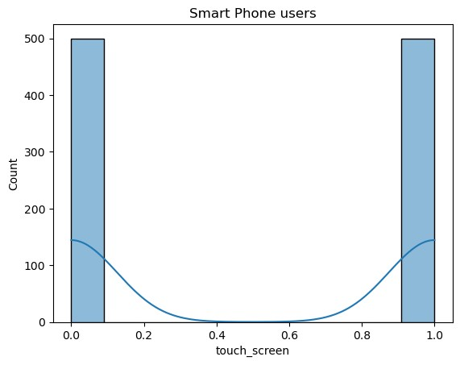
sns.histplot(mobiles["clock_speed"],kde=True).set_title("Clock speed of mobiles") plt.show()
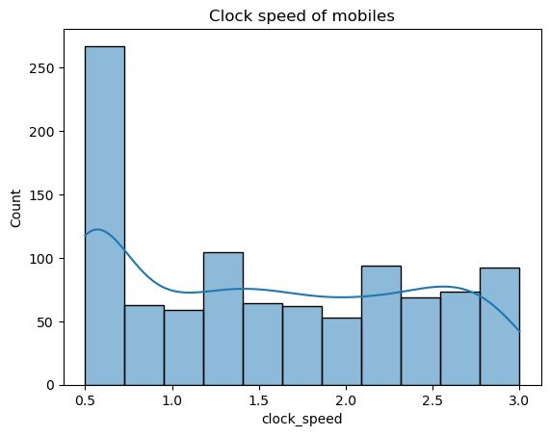
sns.histplot(mobiles["mobile_wt"],kde=True).set_title("MObile Weight
Distribution") plt.show()
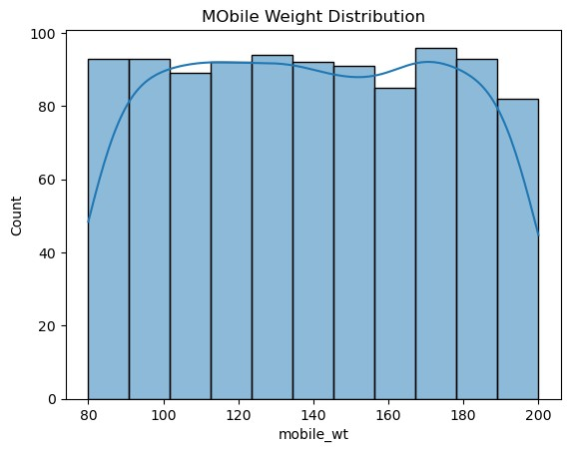
sns.countplot(x='battery_power', data=mobiles).set_title('Time') plt.show()
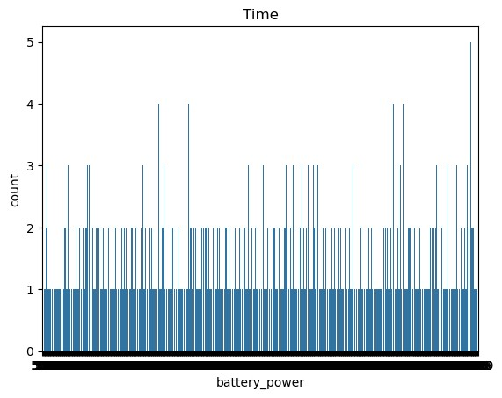
gender_counts = mobiles['talk_time'].value_counts() plt.figure(figsize=(6, 6))
plt.pie(gender_counts, labels=gender_counts.index, autopct='%1.1f%%', startangle=140)
plt.title('Time based on talktime') plt.show()
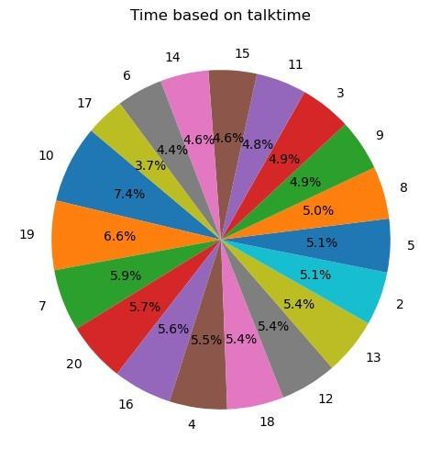
sns.scatterplot(x='battery_power', y='talk_time',hue='touch_screen', data=mobiles, alpha=0.8)
plt.title('Battery POwer vs Talk time in smart phones') plt.xlabel('battery_power') plt.ylabel("talk_time") plt.grid(True) plt.show()
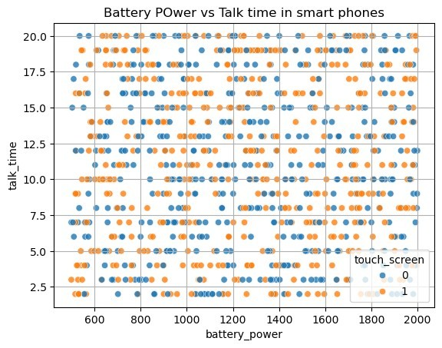
# Scatter Plot: Price vs Battery Capacity
plt.figure(figsize=(7, 5))
sns.scatterplot(x=mobiles['battery_power'], y=mobiles['mobile_wt'], hue=mobiles['clock_speed'], palette='tab10') plt.title("Battery Capacity vs mobile_wt") plt.xlabel("Battery Capacity (mAh)") plt.ylabel("Price in India") plt.grid(True) plt.show()
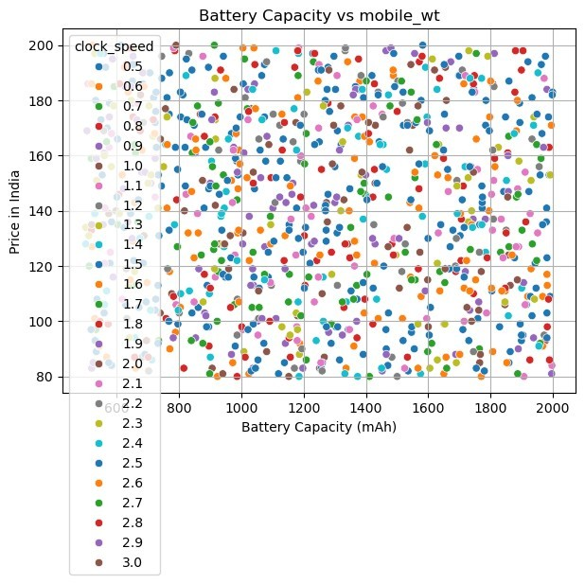
# Scatter Plot: Screen Size vs Mobile Weight
plt.figure(figsize=(7, 5))
sns.scatterplot(x=mobiles['sc_h'], y=mobiles['mobile_wt'], hue=mobiles['talk_time'], palette='Set2') plt.title("Screen Size vs Mobile Weight") plt.xlabel("Screen Size (inches)") plt.ylabel("Mobile Weight (g)")
plt.grid(True) plt.show()
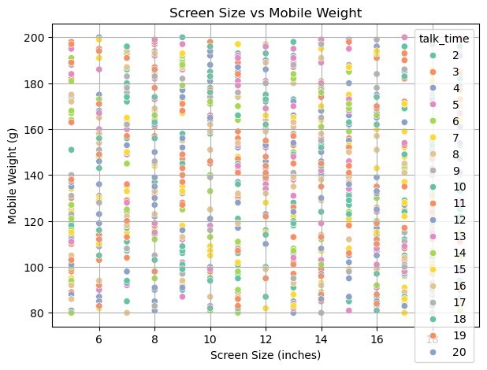
# Correlation Heatmap
plt.figure(figsize=(10, 6))
corr =mobiles[['mobile_wt', 'battery_power', 'sc_h', "clock_speed", 'touch_screen']].corr() sns.heatmap(corr, annot=True, cmap='coolwarm', fmt=".2f") plt.title("Correlation Matrix") plt.show()
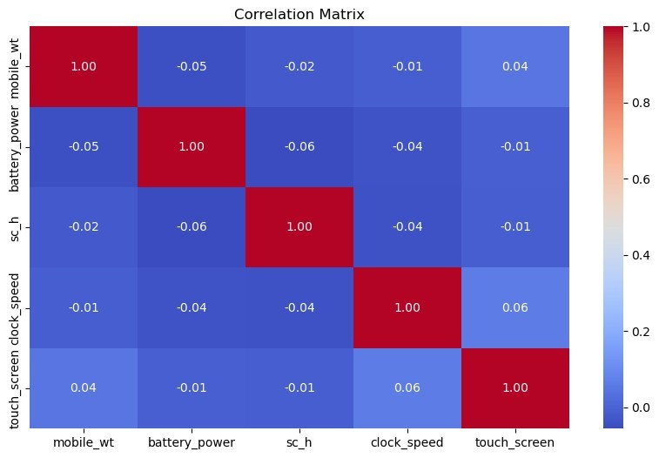
# Grouped Analysis: Average Price by Company
plt.figure(figsize=(10, 5))
grouped = df.groupby('id')[['touch_screen',
'battery_power']].mean().sort_values(by='touch_screen', ascending=False)
grouped.plot(kind='bar', figsize=(12, 6), colormap='tab20') plt.title("Average Touch screen phones and Battery Capacity by Company") plt.ylabel("Value") plt.xticks(rotation=45) plt.grid(True) plt.tight_layout() plt.show()

